Homework 5 Answer key 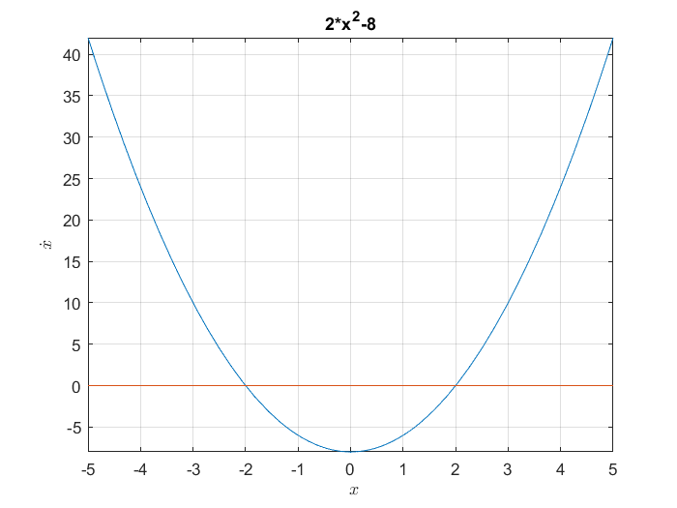



There is one stable fixed point at x = -2 and one unstable fixed point at x = 2.

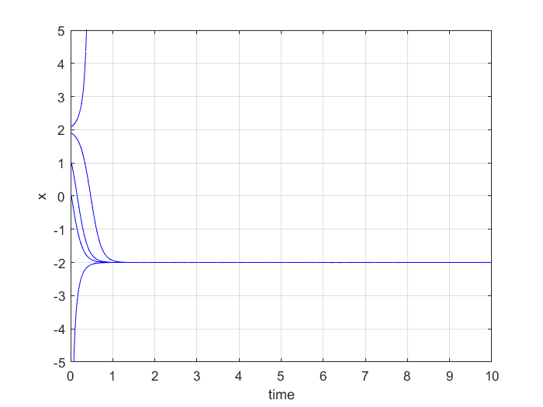

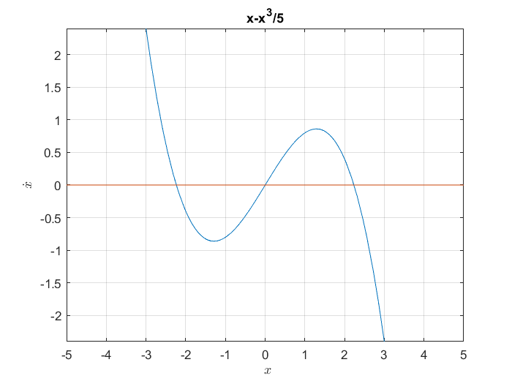



There are two stable fixed points at x = +-sqrt(5) and one unstable fixed point at x = 0.

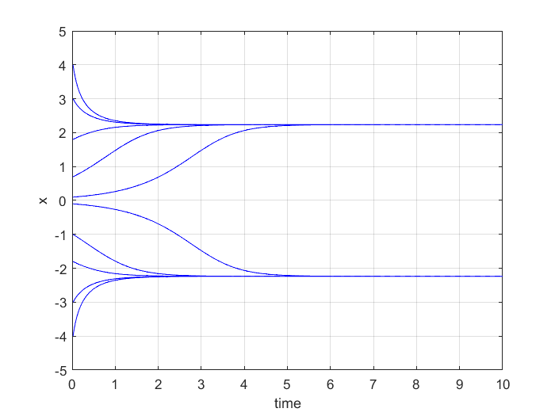

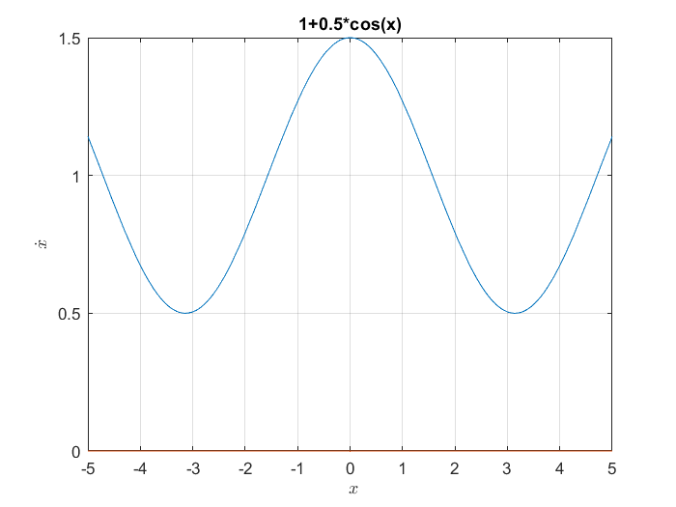

There are no fixed points for this model because the graph of the function does not cross 0. The model always increases in state (x) from any initial condition.

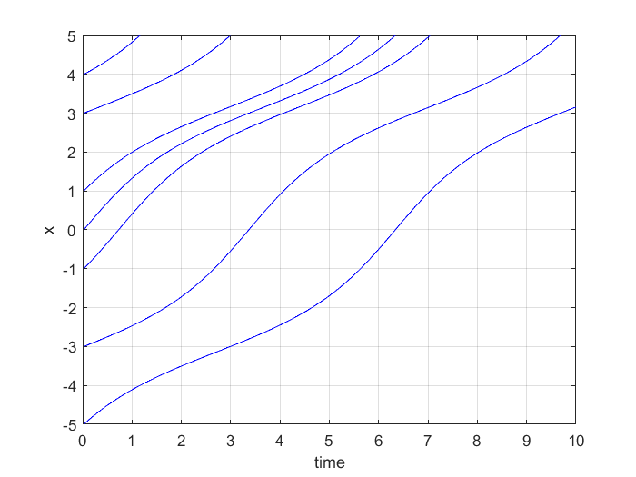

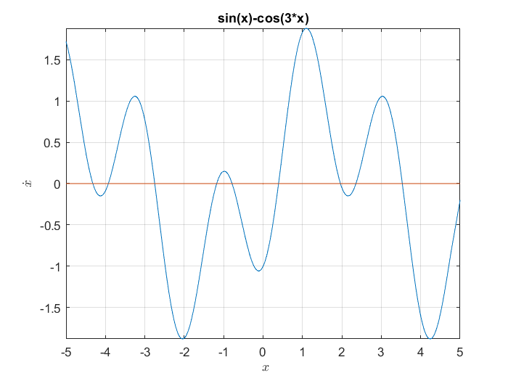



This function is periodic, so there many fixed points, but I zoomed in to a section that repeats itself to identify the pattern of fixed points.

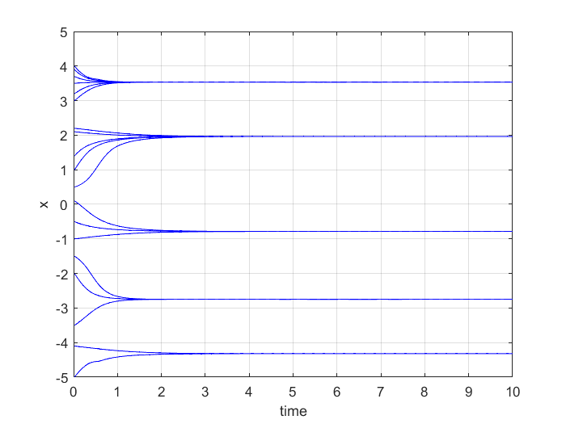

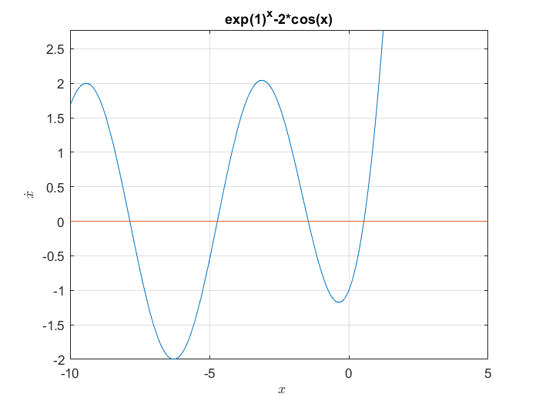



This function is also periodic (cos), but diverges to infinity after 0. So, all the fixed points are to the negative side from around 0.



